TES Code Issues:

1. Excessive use of Sessions.

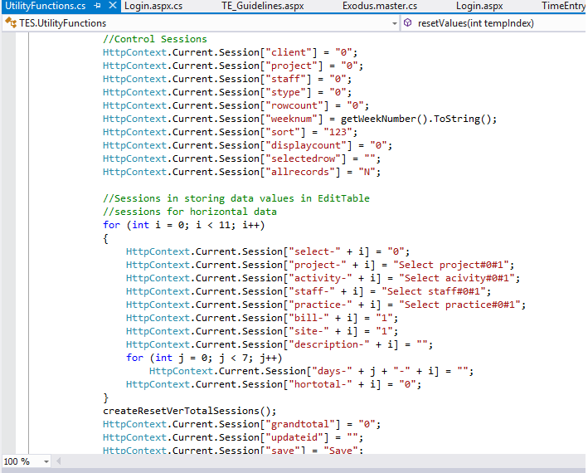

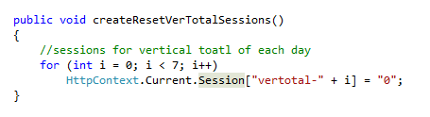

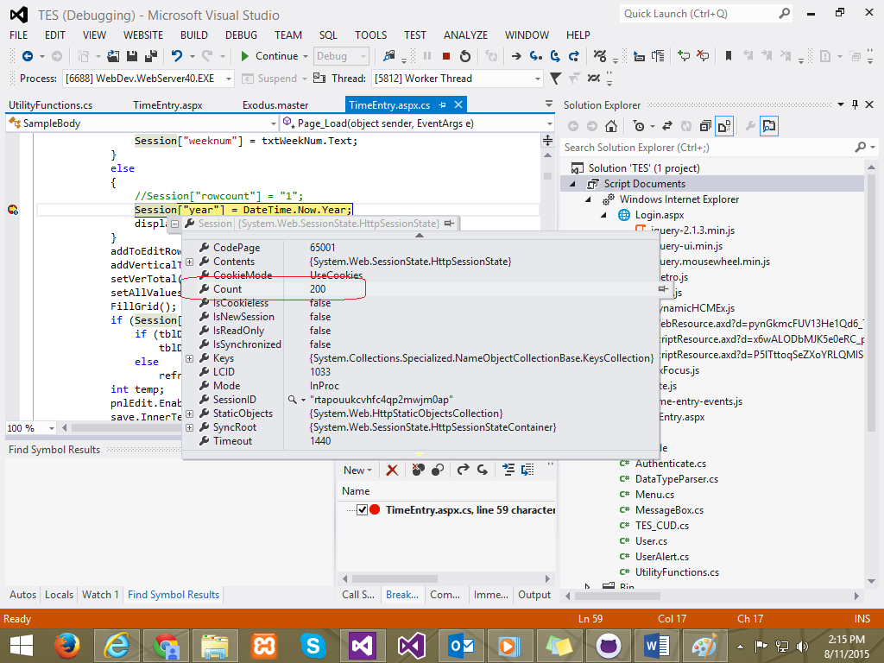

These sessions were used to store data for each field, during auto-postback. This may harm the performance of the system when extended.

1. Dynamically created objects, rendered at the server side. 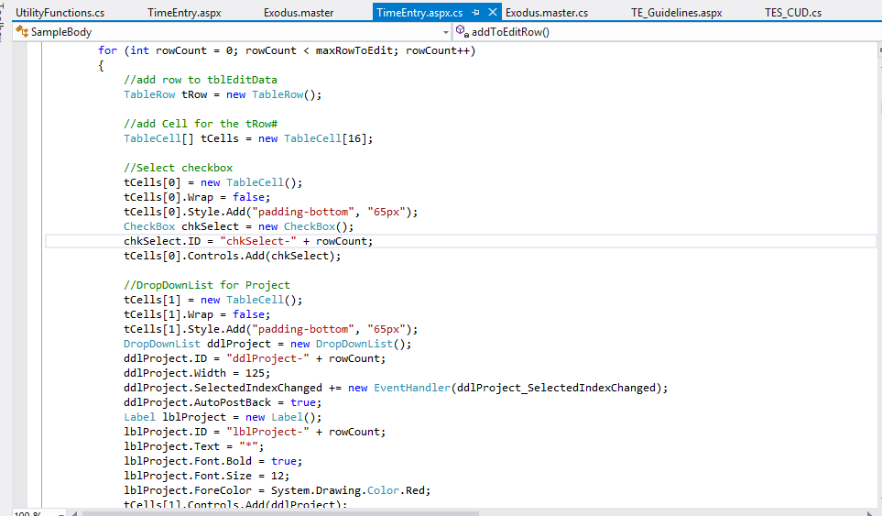
2. Procedural Programming and unstandardized code.

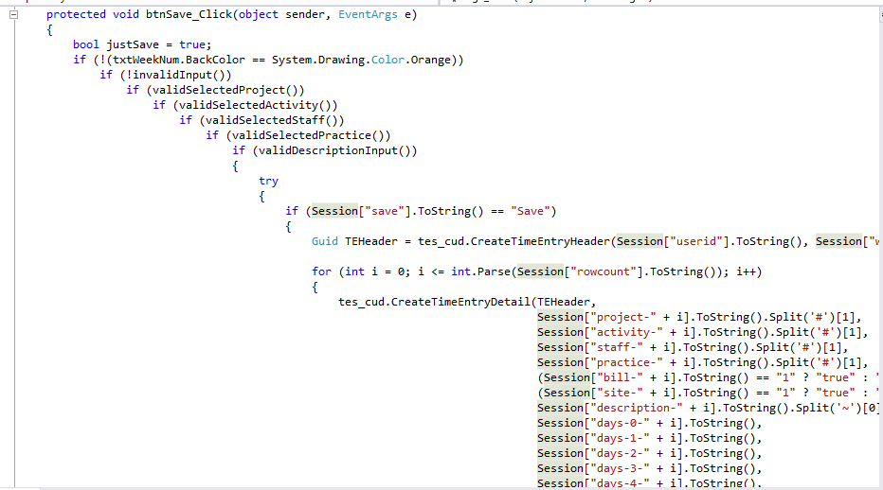

Unstandardized code and Procedural Programming will drastically reduce the flexibility, maintainability and scalability of a software. The issue can be resolved by applying Object Oriented Programming during development.